Theory Section

1. [3 pts] Describe the difference between an identity column and a sequence

**Identity Column is part of the table, while a sequence is a separate database object.**

**A sequence can be used for more table**

1. [3 pts] What are the 4 states of the entity life cycle?

**Transient, Managed, Detached, Removed**

1. [3 pts] Changes to detached objects don't automatically go into the DB. What do you need to do if vou want to have changes applied to a detached object go to the DB?

**em.merge() make the detached object managed again, and then its changes will go into the DB**

1. [3 pts] What is meant with shared primary key in the context of a One ToOne association?

**Both tables have the same primary key value which they use as a foreign key to connect (OneToOne) @MapsId can be used for that**

1. [3 pts] Describe what the orphan removal cascade does:

**When the reference between the objects is removed, orphan cascade deltes the object that is no longer referenced.**

1. [3 pts] What is the difference between a Bag and a List:

**Bag has no order and can contain duplicates**

**A List has an intrinsic order and can contain duplicates. In order to have a real list in the DB you need an additional index column**

1. [3 pts] What causes the Cartesian product problem?

**Joining 2 or more collections**

1. [3 pts] Describe the Lost Update Problem in DB concurrency

**When running a database in read-committed isolation level (or lower) there is a chance that two transactions run at the same time writing it same data, one will commit first, then the other.**

**The one that went first, it's data is overwritten (lost) when the second one commits.**

**You can avoid this by adding @Version!**

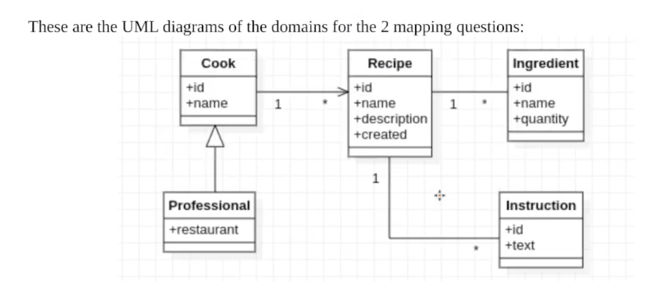

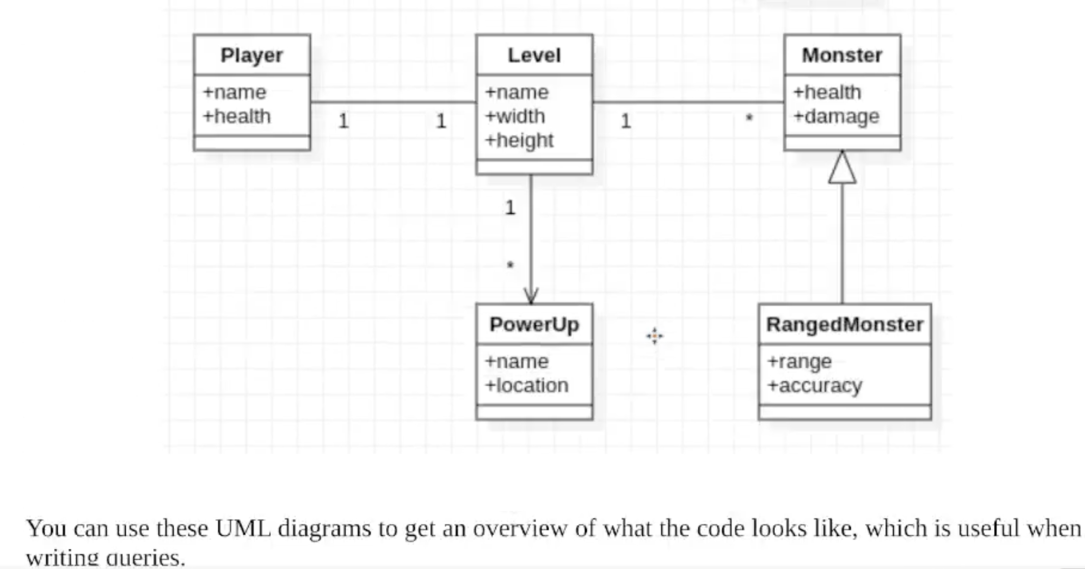

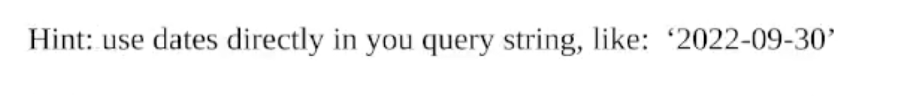

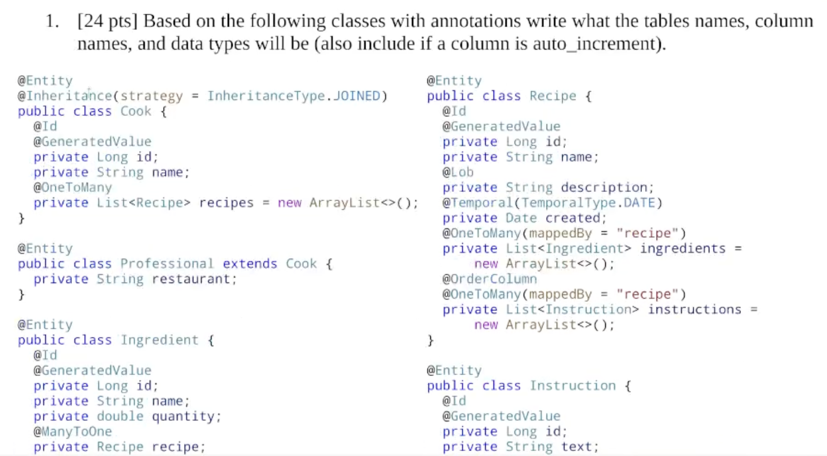 

**ANSWER**

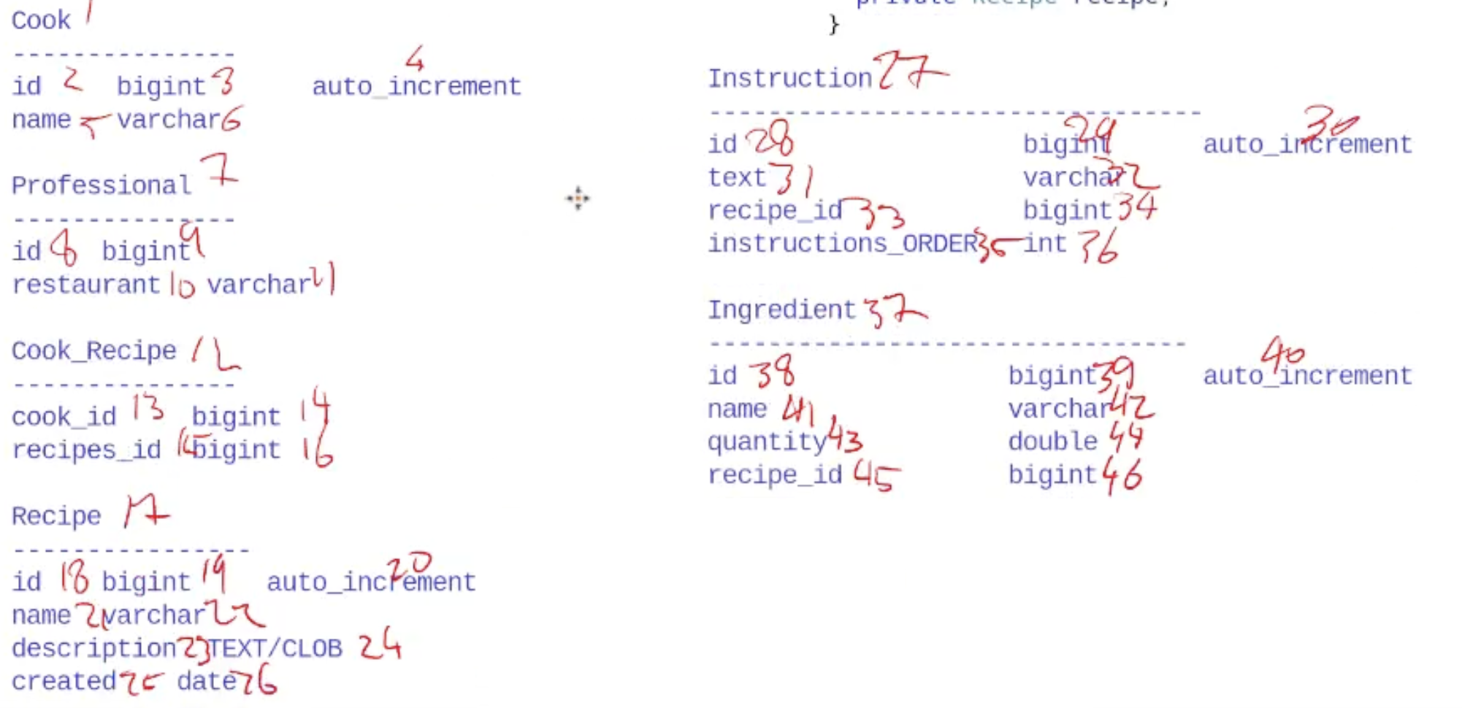

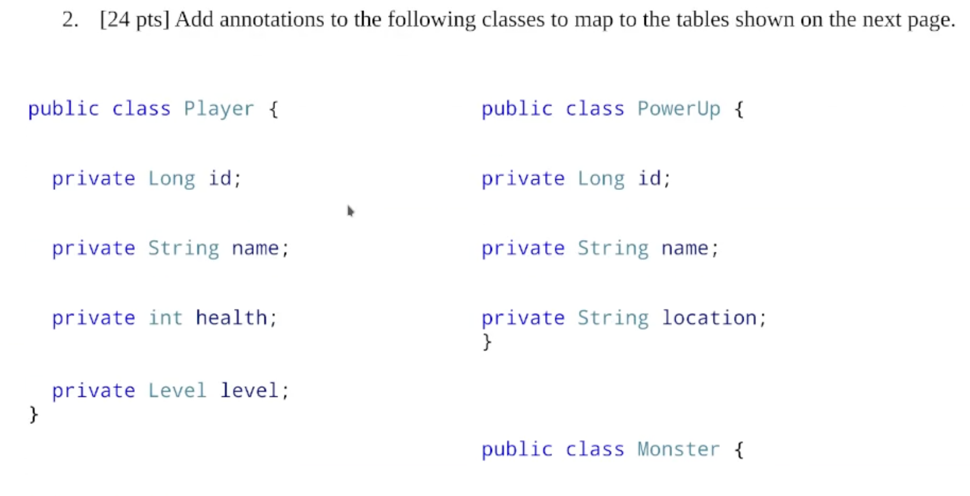 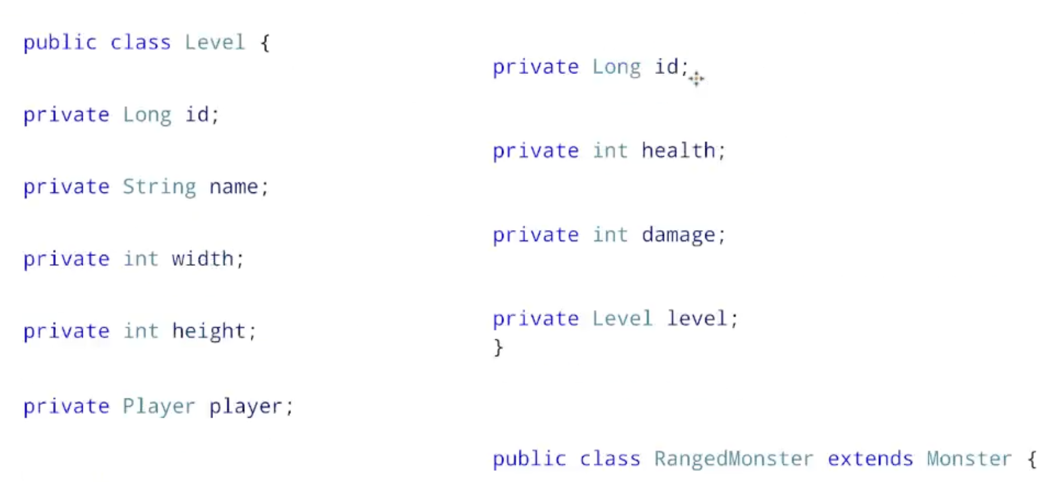 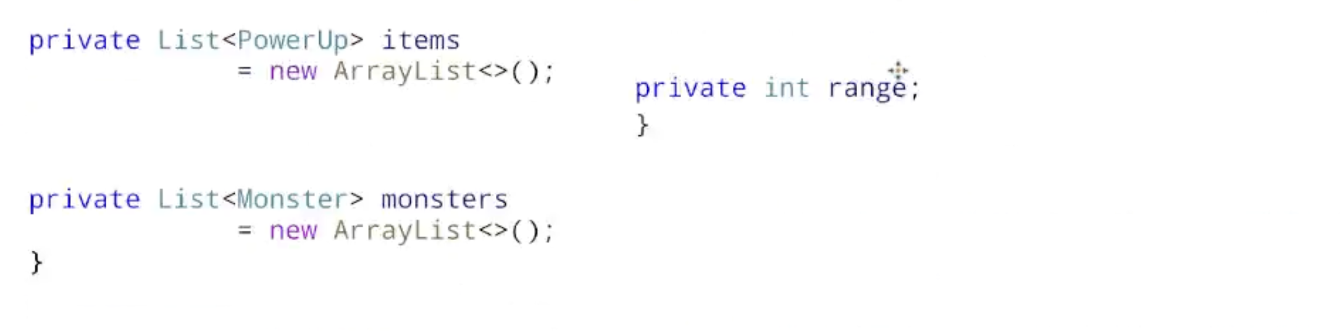

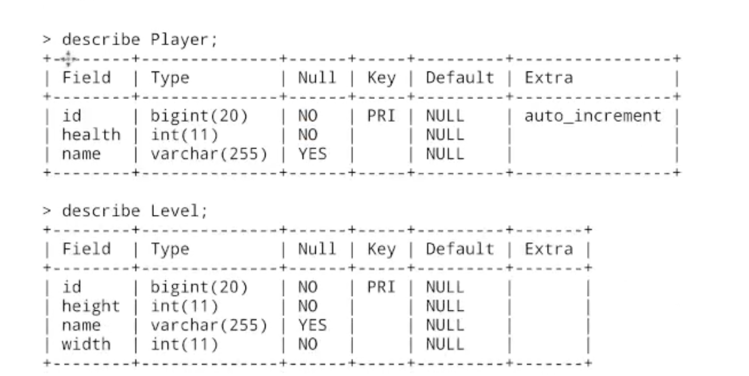

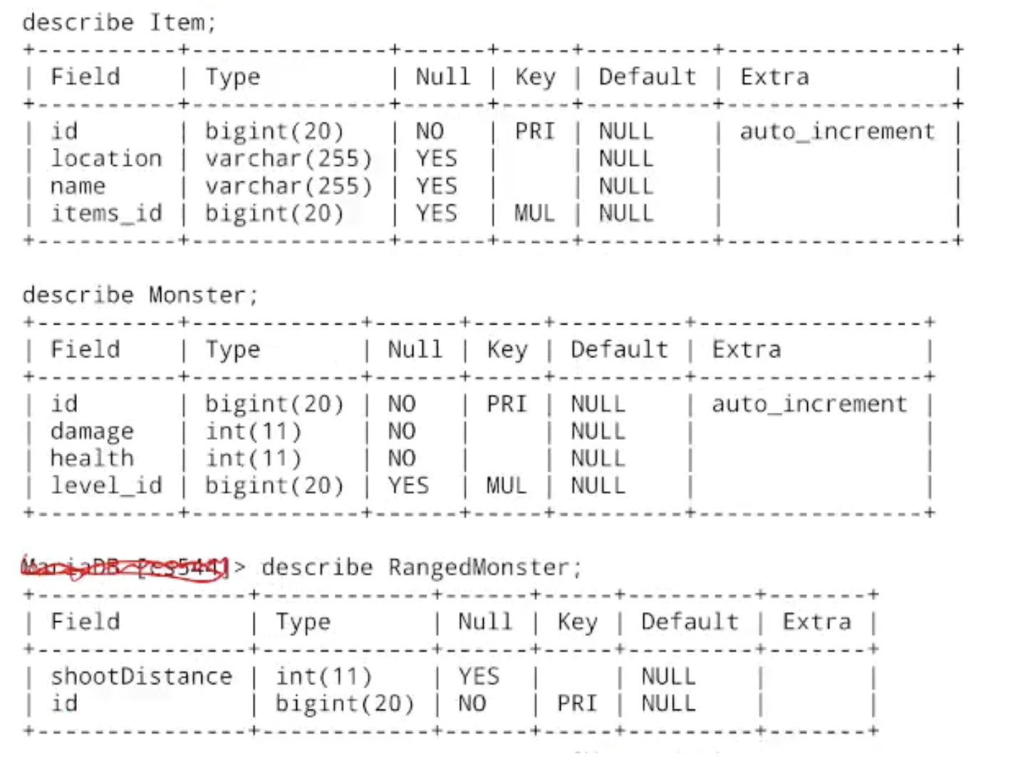

**ANSWER**

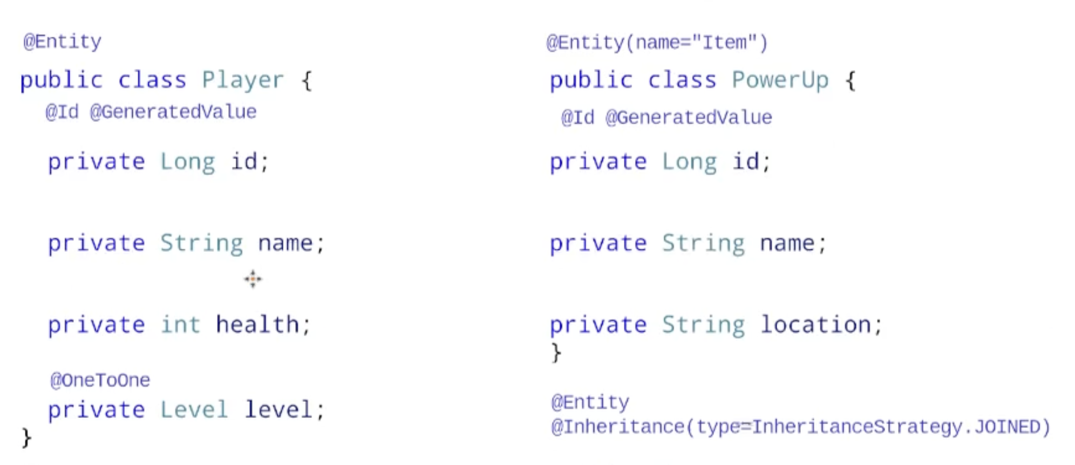 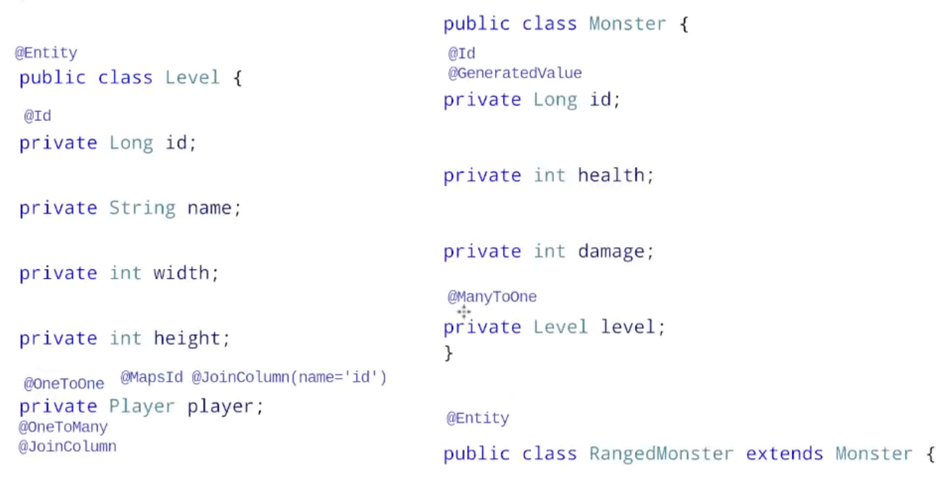 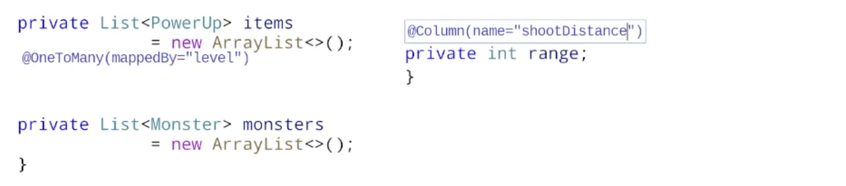

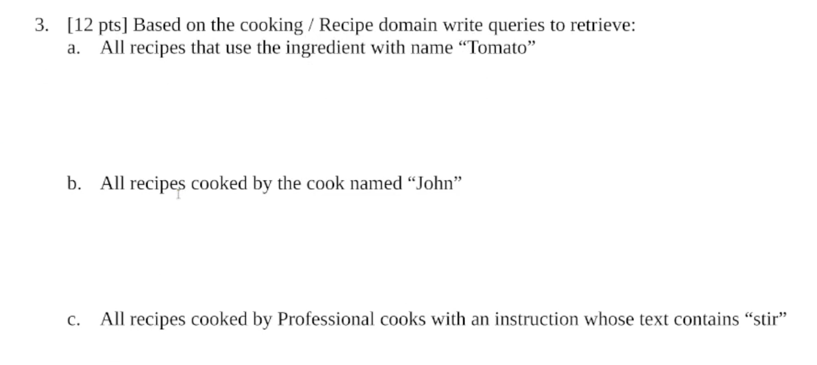

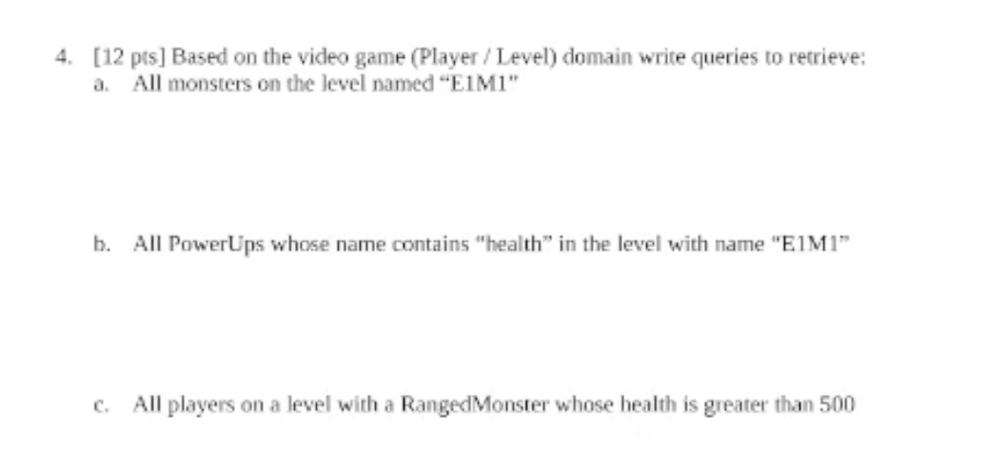

**ANSWER**



